Lab 12.1

Anjalee Daowdat

* Click to Launch [Create a Basic Wireframe and Prototype with Figma](https://help.figma.com/hc/en-us/articles/13666942319127-Create-a-basic-wireframe-and-prototype)

Using Figma , create a wireframe for each of the Final Project three pages

Add a screenshot of the Wireframe for Page 1: About Us

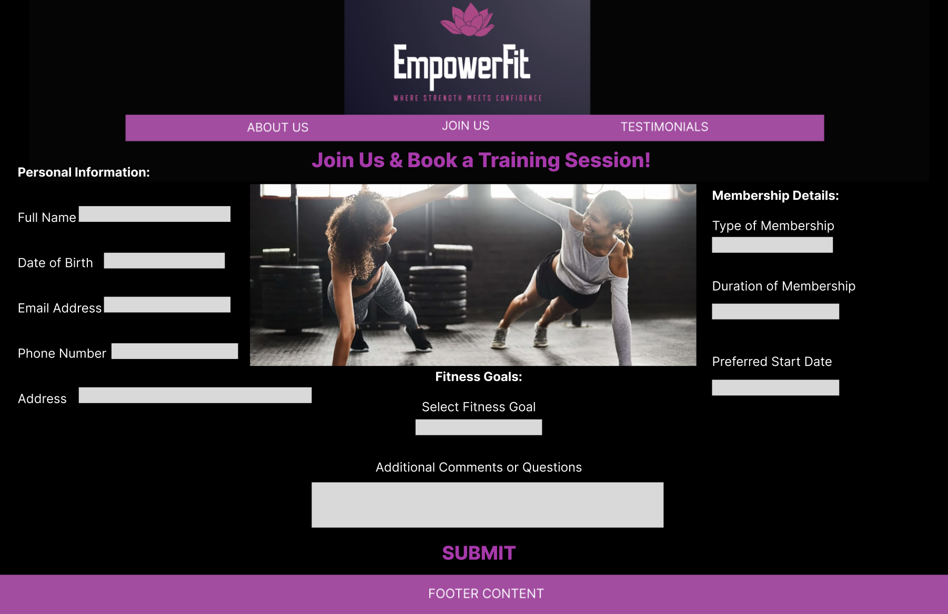Add a screenshot of the Wireframe for Page 2: Membership Form

Add a screenshot of the Wireframe for Page 3: Creativity Page